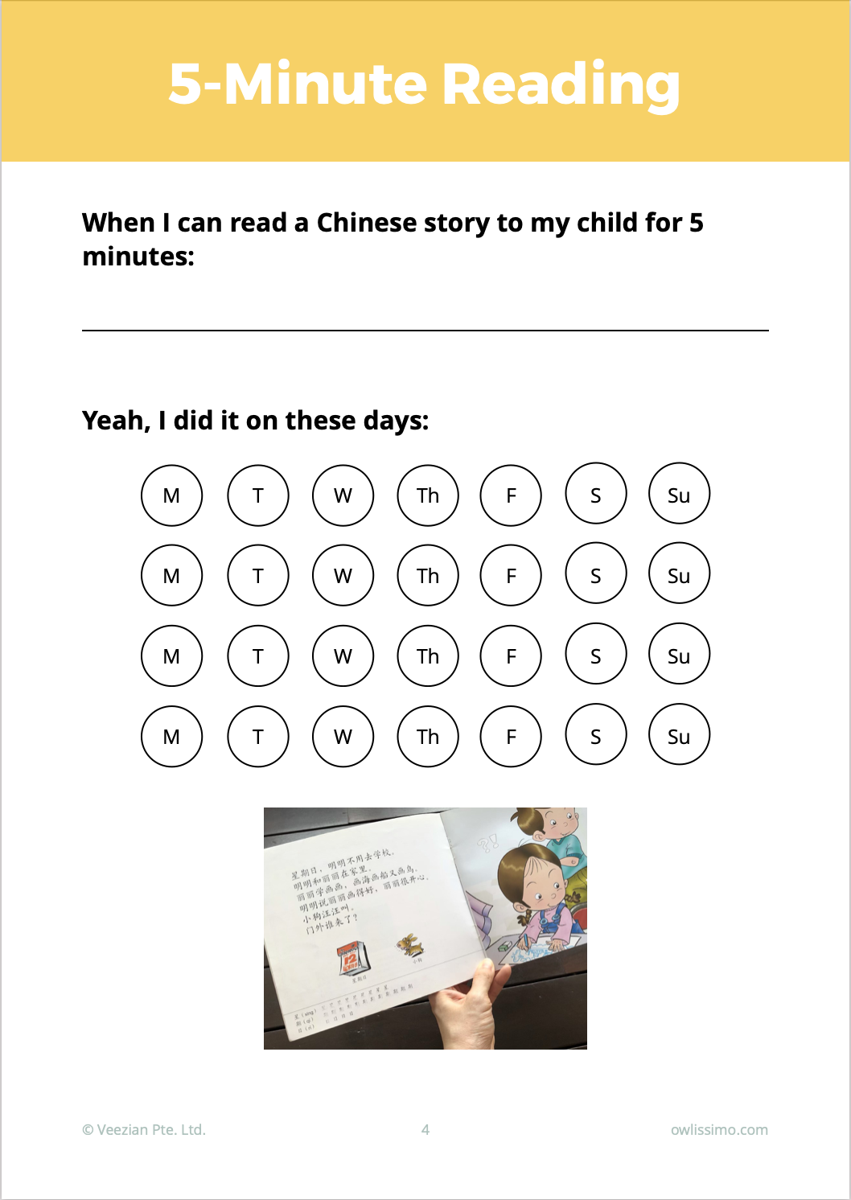

Type to enter text

Copy & paste the smiley face